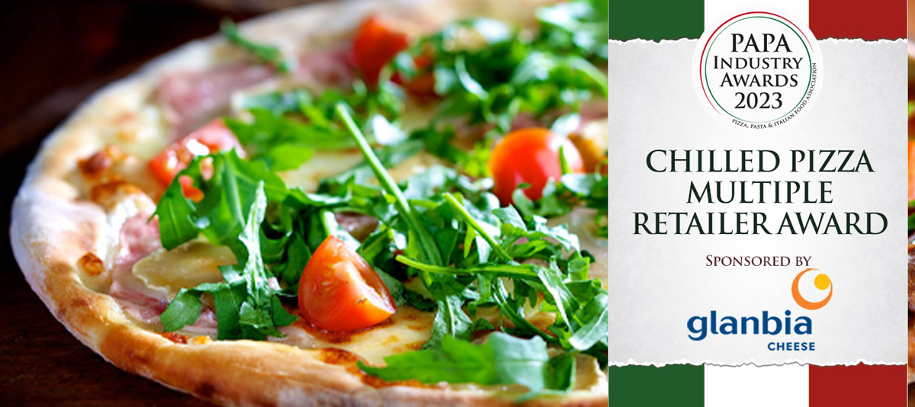

Award Qualifying Period
1st September 2022 to 31st August 2023

Closing Date
23:59hrs - Wednesday 9th August 2023

Please complete the required information below and the full award details can be found on the website – www.papaindustryawards.co.uk

Contact Name:
Position:
Business Name:
Address:
Postcode:
Business Tel:
Mobile:
Contact E-Mail:

Please provide any additional information below to support your entry and why you deserve to win this award
Other supporting material may be sent together with your entry

