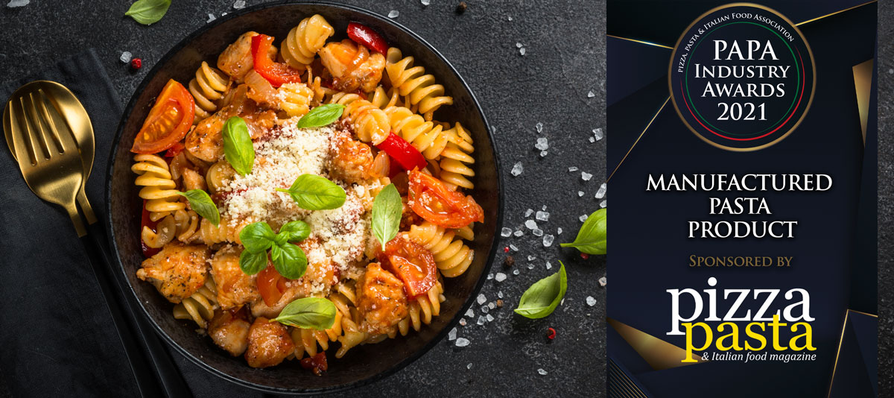

About the Award
This award aims to find the best new pasta product launched in the last year and includes frozen, fresh and dry products.

Entry Requirements
- Entries should be for single products not ranges.
- Maximum of three product entries
- Products should have been launched within the 12-month award period.
- Entrants should state why products deserve to win and highlight any innovative features.
- Products should continue to be on sale at the time of the awards.
- Those entrants initially shortlisted will be asked to deliver sample products for judging.
- Judging will take account of innovation as well as taste and presentation.
The final shortlisted entrants will be invited to present their products to our judges and members online for voting.

Award Qualifying Period
1st September 2020 to 31st August 2021

Closing Date
12th August 2021
Contact Name:
Position:
Business Name:
Address:
Postcode:
Business Tel:
Mobile:
Contact E-Mail:
Category (delete as appropriate): Fresh or Dry or Frozen
Launch Date:
Retail Price:
Please provide your written submission here
Continue as necessary to a maximum of two sheets of A4
Other supporting material may be sent separately

