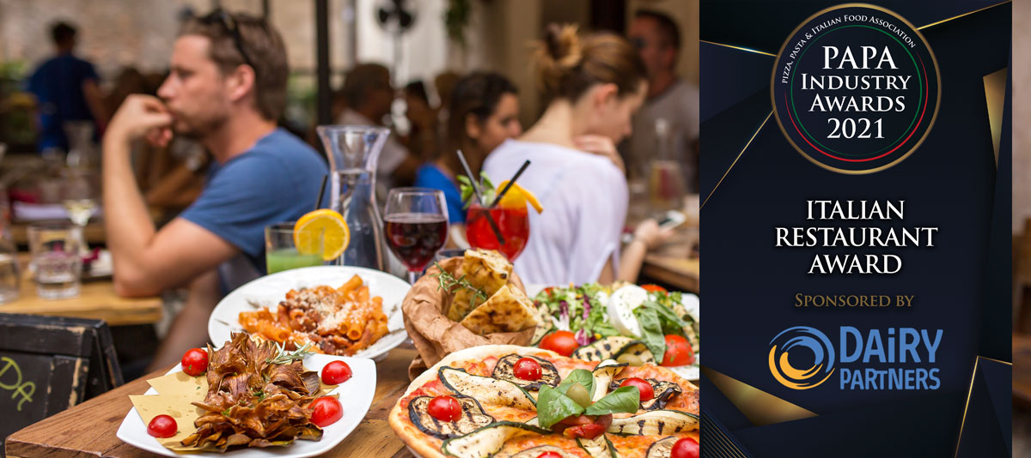

About the Award
Open to all Italian Restaurants regardless of the number of sites, this award aims to recognise those who have done the most to keep their businesses going through lockdown. whether by developing ingenious ways to deliver their meals or by giving support to the NHS or their communities.

Entry Requirements
- All entries must have a food hygiene rating of five.
- Judges will take into account research data from Kantar, Lumina Intelligence and Mealtrak, where available.
- In some categories, independent judges may visit sites to conduct a ‘mystery shopper visit’.
- Entrants are encouraged to submit an entry stating why they think they should be considered for an award – this should be no more than one side of an A4 sheet.
- Consideration will be given to how businesses have managed during lockdown.
- The judges may give gold and platinum awards

Award Qualifying Period
1st September 2020 to 31st August 2021

Closing Date
Thursday 12th August 2021

Contact Name:
Position:
Business Name:
Address:
Postcode:
Business Tel:
Mobile:
Contact E-Mail:
Please provide your written submission here
Continue as necessary to a maximum of two sheets of A4
Other supporting material may be sent separately

